

College of Arts and Science

Final Year Project

Summer 2025

**Project Report**:

Blockchain-Enabled Medical Report Management and Distributed Systems

**Report Submitted by:**

Mustafa Jumaa

Jad Habli

Khalil Al Masri

Tarek Jbeili

**Report Submitted to:**

Dr. Ghalia Nassreddine

This senior project was submitted in partial fulfillment of the requirements of the Bachelor of Science degree of Computer Science Major of the College of Arts and Sciences at Rafik Hariri University.

MECHREF, LEBANON

August 2025

Copyright © 2025, all rights reserved

Mustafa Jumaa (2022- 0272)

Jad Habli (2022-0309)

Khalil Al Masri (2021-0617)

Tarek Jbeili (2020-0050)

# **Acknowledgments**

We extend our heartfelt appreciation to our research supervisor, Dr. Ghalia Nasereddine,

Ph.D. in Computer Science, for her invaluable guidance and continuous support throughout the

development of this project. We are also extremely grateful to Dr. Mohammad El Abed,

Associate Professor and Chairman of the Computer and Information Systems Department, for his

assistance and continuous support. Additionally, we would like to express our sincere thanks to

the esteemed faculty members of the Computer Science major, including Dr. Roaa Al-Soloh and

Dr. Ali Rammal, for their contributions and guidance throughout our academic journey.

# **Abstract**

In today’s fragmented healthcare ecosystem, securing medical reports while enabling cross-provider collaboration faces critical challenges: non-interoperable data silos, vulnerability to breaches, and rigid access controls that compromise patient care. Traditional Electronic Health Record (EHR) systems struggle to share data across hospitals, pharmacies, and labs—delaying treatment and increasing administrative burdens. To resolve this, we built a Blockchain-Enabled Medical Report Management System that pioneers universal interoperability through:

1. HL7/FHIR-compliant data schemas allowing seamless integration with existing hospital/lab systems
2. Cross-institutional APIs that let providers access authorized records without platform migration
3. Standardized patient DIDs functioning as portable identities across all healthcare entities

By leveraging Ethereum smart contracts for consent management and IPFS for encrypted storage, our solution ensures secure, real-time data fluidity between stakeholders while maintaining HIPAA/GDPR compliance. Patients control data sharing via unified interfaces (WCAG 2.1-compliant), eliminating redundant tests and paperwork. This architecture transforms isolated records into a collaborative care network—where hospitals view histories, pharmacies verify prescriptions, and labs upload reports to a single patient-owned ledger.

Keywords: Blockchain, Electronic Health Records, Data Storage, Security, Patient Agency, Decentralized, Custom Blockchain

# **Table of Contents**

Contents

**Acknowledgments** 3

**Abstract** 4

**Table of Contents** 5

**List of Figures** 6

**List of Tables** 6

**Introduction and Motivation** 7

**Chapter 1** 8

Literature Review 8

**Chapter 2** 13

System Requirements Analysis and Design 13

**I.** **Introduction** 13

**II.** **Requirements** 13

**III.** **Use Case Diagram** 16

**IV.** **Sequence Diagram** 17

**V.** **Architecture of the Medical Report Management System** 18

**Client-Side (Front-End)** 18

**VI.** **Data Modeling** 20

**VII.** **Technologies Used** 24

**VIII.** **Conclusion** 25

**Chapter 3** 25

System Analysis 25

**I.** **Introduction** 25

**II.** **Data Modeling and Integration of Blockchain Transactions with IPFS Storage** 27

**III.** **Smart Contract Design for Access Control, Consent Management, and Auditing** 27

**IV.** **Front-End Integration (ReactJS) with Web3.js/Ethers.js for Blockchain Communication** 27

**V.** **Authentication Workflows Using Firebase Authentication and Cryptographic Wallets** 28

**VI.** **Testing and Validation of Report Uploads, Access Permissions, and Data Retrieval Workflows** 28

**VII.** **Conclusion** 29

**Chapter 4** 29

Implementation 29

**I.** **Introduction** 29

**II.** **Front-End Implementation (Client-Side)** 30

**III.** **Middleware and Blockchain Integration** 37

**IV.** **Data Storage and Management (IPFS + Firebase)** 38

**V.** **Authentication Workflows** 40

**VI.** **Testing and Validation** 41

**VII.** **Summary of Implementation** 41

**Conclusion and Perspectives** 43

References 44

**Appendix** 45

# **List of Figures**

Figure 1 Use Case digram 17

Figure 2 Sequence diagram 1 18

Figure 3 Architecture of the Website 20

Figure 4 Entity Relations diagram Sample: HOSPITAL 22

Figure 5 Entity Relations diagram Sample: LAB 23

Figure 6 represents the Blockchain architecture 24

Figure 7 represents the smart contract architecture 25

Figure 8 Sign in 31

Figure 9 Admin Hospital signing in 32

Figure 10 mongoDB authentication 32

Figure 11 Shows Patient Dashboard 33

Figure 12 shows new and old records 33

Figure 13 shows Hospital Administrator Dashboard 34

Figure 14 Shows Audit logs 35

Figure 15 shows Pathology Lab Dashboard 36

Figure 16 All pathology patient overview 36

Figure 17 Single patient overview 37

Figure 18 Shows pathology lab uploading a record 38

Figure 19 shows pathology lab record uploaded and doctor exported result to json file as well 38

Figure 20 Intial plan to use a private blockchain 39

Figure 21 Used mongoDB instead of firebase due to constraints 42

# **List of Tables**

Table 1 provides an overview of the advantages of Blockchain + NoSQL (Firestore) + IPFS hybrid architecture compared to traditional relational databases for medical report management. 18

# **Introduction and Motivation**

In today’s rapidly evolving healthcare landscape, the security and accessibility of patient data remain critical challenges. Electronic Health Records (EHRs), while streamlining clinical workflows, are increasingly vulnerable to cyber threats, unauthorized access, and data breaches. This compromise of sensitive information—ranging from personal details to medical histories—not only erodes patient trust but also hinders seamless collaboration among healthcare providers. In 2017, Airway Oxygen, Inc suffered a data breach from which impacted more than 500,000 people according to a report by Alder, (2018) published in the HIPAA Journal. The urgent need to reconcile robust data security with efficient accessibility calls for transformative technological solutions.

Blockchain technology, with its decentralized architecture and cryptographic foundations, offers a revolutionary approach to safeguarding medical data. By design, it eliminates single points of failure, ensures data immutability, and grants granular control over information access. This project directly addresses the critical gap in modern healthcare systems by leveraging blockchain to create a secure, transparent, and interoperable platform for medical report management.

Our project adopts a modular, user-centric framework to serve diverse stakeholders such as:

* Hospitals
* Pharmacies
* Pathology labs
* Patients
* Caregivers

while prioritizing end-to-end security. Through agile development and continuous iteration, we ensure adaptability to evolving regulatory and technical demands. The system integrates blockchain protocols with intuitive web interfaces, enabling:

* Tamper-proof storage of medical reports via decentralized ledgers
* Role-based access control for hospitals (full oversight), pharmacies (billing management), and labs (report generation/viewing).
* Cryptographic security to protect patient data at every touchpoint.
* Real-time, auditable data sharing among authorized entities.

Technology Stack

* Front-End: React.js, JavaScript, HTML5, CSS3
* Middleware/Web3: Ethers.js / Web3.js for blockchain interaction
* Back-End: Firebase / MongoDB (Authentication, Storage)
* Blockchain: Ethereum (smart contracts, audit logs)
* Storage: PINATA IPFS (for encrypted medical records)

By harmonizing impenetrable security with effortless usability, this initiative aims to redefine medical data stewardship—empowering providers, protecting patients, and advancing the future of digital healthcare.

Key Project Goals:

1. Develop a blockchain-backed platform for secure medical report distribution.

2. Ensure HIPAA/GDPR-compliant data handling through encryption and decentralization.

3. Streamline cross-institutional workflows among hospitals, pharmacies, and labs.

4. Provide patients and caregivers with controlled, transparent access to health records.

5. Eliminate data silos while preventing unauthorized breaches or manipulation.

# **Chapter 1**

# Literature Review

Introduction

The integration of blockchain technology into the healthcare domain has become a growing field of study due to the rising concerns around data privacy, interoperability, and patient autonomy in Electronic Health Record (EHR) systems. Traditional health data infrastructures often rely on centralized databases, leaving sensitive patient data vulnerable to breaches, manipulation, or inaccessibility during emergencies. Blockchain introduces the possibility of decentralized, tamper-resistant, and traceable health data management that prioritizes transparency and patient control.

In this chapter, we explore notable blockchain-based healthcare solutions that have influenced the design of our system. These include MedRec, BurstIQ, and the UAE’s Riayati initiative. By critically analyzing the structure, strengths, and shortcomings of each system, we identify the gaps that our proposed platform aims to fill — particularly in terms of full decentralization, patient-centric control, and scalability tailored for developing regions like Lebanon.

Review of Existing Systems

1. MedRec (MIT)

MedRec is one of the earliest efforts to utilize blockchain technology in healthcare, developed by researchers at MIT. It operates on the Ethereum blockchain and is primarily focused on managing permissions rather than storing actual health data on-chain. The platform allows healthcare providers and patients to access a unified view of medical history by using smart contracts to log and manage access to off-chain records.

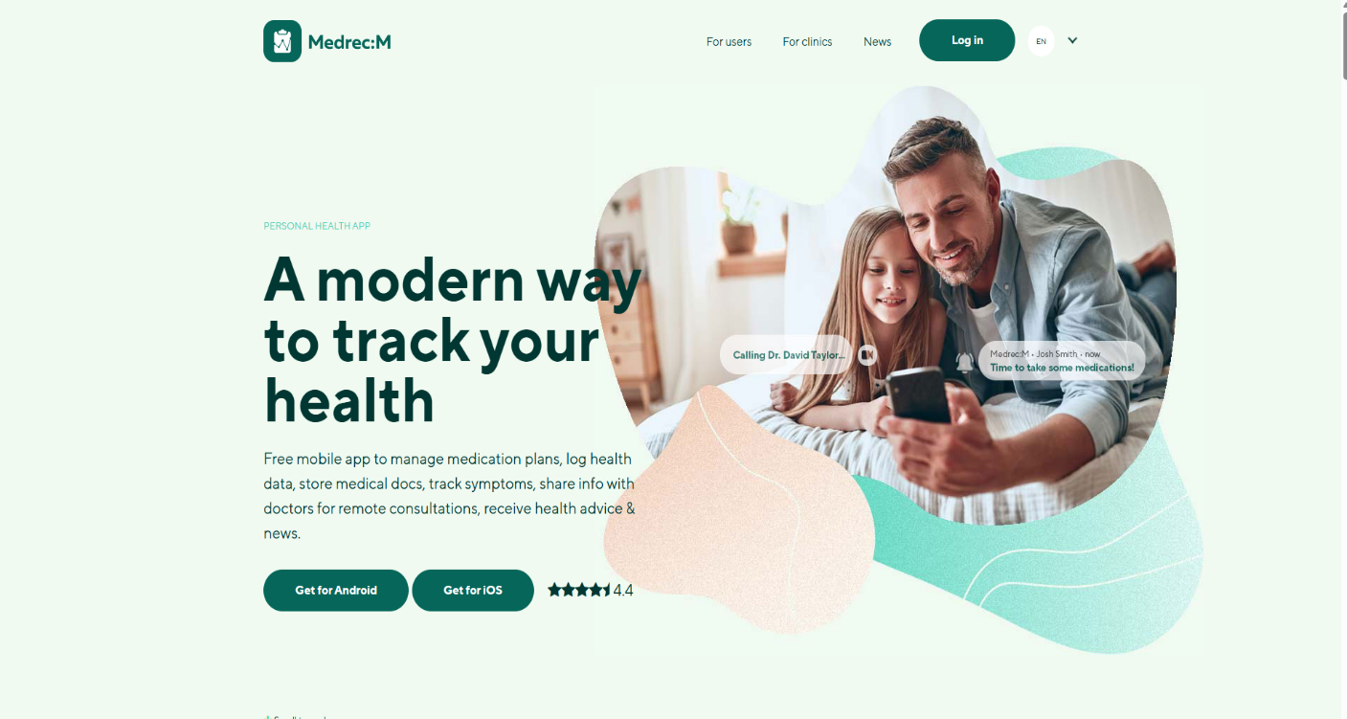

**Strengths**

* Pioneered blockchain use in EHRs.
* Utilizes smart contracts for permissions management.
* Offers patients a certain degree of control over their medical data access.

**Weaknesses**

* Built on Ethereum, resulting in scalability concerns due to gas fees and slow transaction speeds.
* Patients still rely on providers to maintain actual medical records.
* Limited customizability for smaller or local healthcare infrastructures.
* Not designed with developing nations in mind, where digital literacy and internet access can vary.

1. BurstIQ

BurstIQ presents a more commercially viable model through its proprietary LifeGraph platform. It emphasizes data ownership, consent management, and health data monetization. By using off-chain storage for actual medical records and maintaining consent and identity data on-chain, BurstIQ delivers a hybrid model of data management.

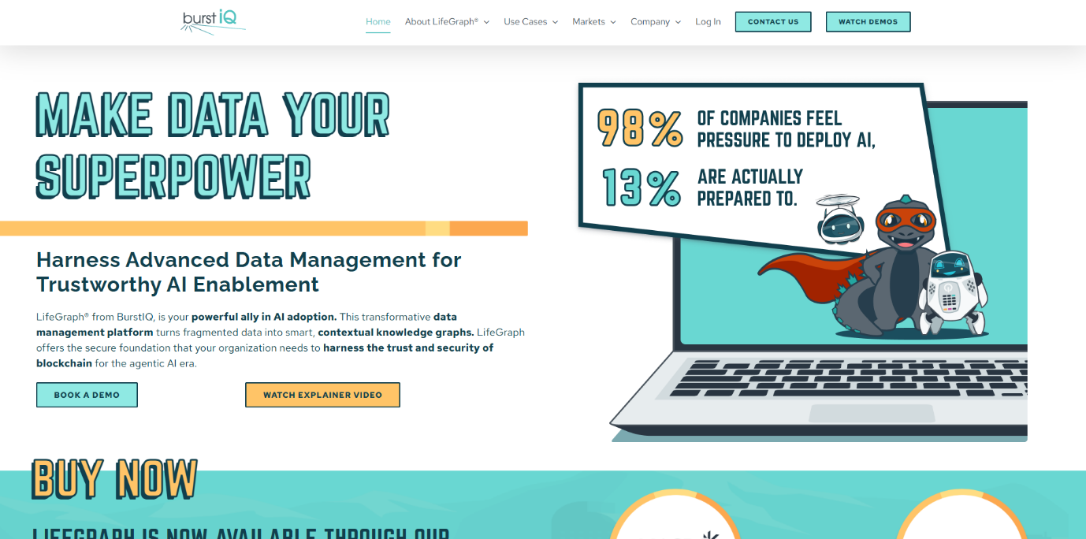

***Strengths***

* Comprehensive consent management and patient ownership features.
* HIPAA-compliant architecture.
* Offers integration with third-party AI/ML systems for health analytics.

**Weaknesses**

* Not open-source and requires subscription or licensing fees.
* Relies heavily on centralized cloud providers for storage, which introduces new security vectors.
* Operates within an enterprise environment, not optimized for open health networks or public infrastructure.

1. UAE Riayati System

Riayati is a government-led initiative that seeks to unify medical records across all health institutions in the UAE. The system is powered by a permissioned blockchain network, allowing for secure, verified access to patient data by authorized health professionals across the country.

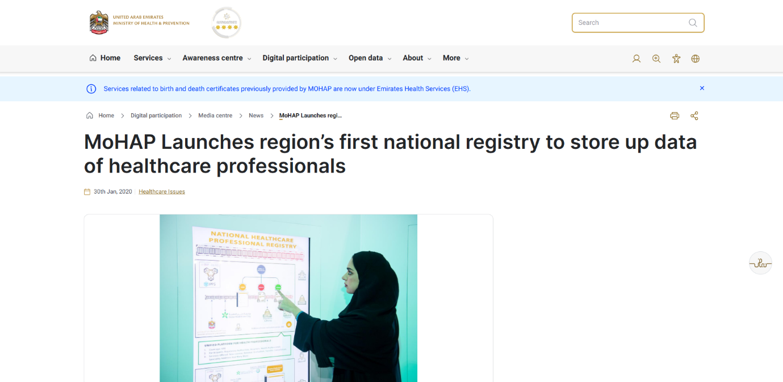

**Strengths**

* Nationwide scope with strong governmental support.
* Focus on data integrity and accessibility in emergencies.
* Real-time updates from hospitals, labs, and pharmacies.

**Weaknesses**

* Maintains centralized control through government infrastructure.
* Does not allow patients to revoke or grant access independently.
* Not adaptable for non-government or private health providers in rural or underserved regions.

Comparative Analysis and System Positioning

While each of the above systems addresses key issues in the healthcare space, they also present limitations that are particularly relevant in the Lebanese healthcare context. Lebanon faces challenges like inconsistent infrastructure, lack of centralized health governance, and low patient empowerment regarding personal health data. Our system distinguishes itself by:

* Building a **custom blockchain** tailored to local infrastructure rather than relying on Ethereum or proprietary platforms.
* Introducing a **double-layered architecture** with **on-chain permissions** and **off-chain encrypted storage** using **Pinata,** ensuring scalability and cost-efficiency.
* Providing **true patient control** over data access through cryptographic keys and a web interface with **fine-grained permissions.**
* Simulating a real-world hospital-lab-patient network using **GNS3,** thereby offering a practical deployment model even in resource-constrained settings.

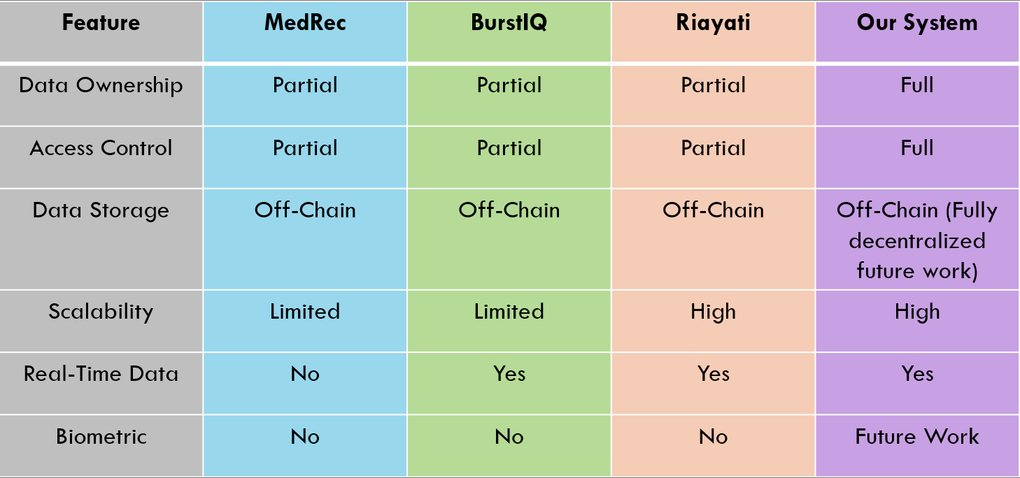

Conclusion

The exploration of MedRec, BurstIQ, and Riayati has offered valuable insights into the capabilities and limitations of blockchain in healthcare. These systems showcase blockchain’s potential to bring security and transparency to medical data management but fall short in delivering a fully decentralized, open-access, and patient-first solution.

Our platform emerges as a hybrid, yet innovative model that bridges these gaps by offering a lightweight, fully customizable blockchain architecture, patient-owned access mechanisms, and simulated network deployment—all of which are designed to meet the practical needs of developing nations like Lebanon. This literature review has shaped the design and motivation behind our proposed solution, validating the critical role of blockchain in the future of healthcare infrastructure.

# **Chapter 2**

# System Requirements Analysis and Design

## **Introduction**

In this chapter, we analyze and design the system requirements for the Blockchain-Enabled Medical Report Management and Distribution System. We detail the collection of requirements, functional/non-functional specifications, use case diagrams, sequence diagrams, application architecture, and the selected technology stack. The chapter is structured as follows:

* Section II: Functional and non-functional requirements
* Section III: Use case diagram
* Section IV: Sequence diagrams for critical workflows
* Section V: System architecture and structural components
* Section VI: Data modeling and blockchain database structure
* Section VII: Implementation tools (front-end, back-end, blockchain frameworks)
* Section VIII: Summary of analysis and design

## **Requirements**

Based on the established stakeholders as well as researching competitors’ platforms, we identified four core user types:

1. Patient/Caregiver: Accesses personal medical reports; grants data-sharing permissions.
2. Hospital Administrator: Oversees all system data and user permissions.
3. Pharmacy User: Manages patient billing and medication records.
4. Pathology Lab User: Uploads, verifies, and views diagnostic reports.

functional requirements for a medical blockchain system:

1. **Functional Requirements**

* **For the Patient:**
  + Upload encrypted medical reports to the system.
  + Grant or revoke access to healthcare providers (hospitals, pharmacies, labs).
  + View medical history, prescriptions, and billing records.
  + Track access logs via blockchain for transparency.
* **For the Hospital Administrator:**
  + Access all patient records with patient consent.
  + Manage pharmacy and pathology lab modules.
  + Audit all system activities through blockchain logs.
  + Ensure compliance with privacy regulations (HIPAA/GDPR).
* **For the Pharmacy:**
  + Access patient prescriptions once consent is granted.
  + Validate prescription authenticity using blockchain hashes.
  + Manage billing records and link them to patients’ medical history.
* **For the Pathology Lab:**
  + Upload diagnostic test results securely to IPFS.
  + Verify integrity of uploaded reports against blockchain records.
  + Share test results with hospitals and patients based on granted permissions.

**Shared Functionalities (All Actors):**

* **User Authentication:**
  + Secure login via Firebase Authentication and/or cryptographic wallets.
  + Role-based access control enforced via smart contracts.
* **Data Sharing and Interoperability:**
  + Patients can authorize cross-hospital data sharing.
  + System supports interoperability with existing Electronic Health Record (EHR) systems, ensuring compatibility and smooth integration.

1. **Non-Functional Requirements**

* **Performance:** The system must handle concurrent uploads, report retrievals, and blockchain transactions efficiently, ensuring low latency.
* **Scalability:** The architecture must support an increasing number of patients, reports, and healthcare providers without degrading performance.
* **Reliability:** The system must ensure high availability and redundancy, preventing downtime in medical emergencies.
* **Security:** All data must be encrypted and protected against unauthorized access. Strong cryptography and blockchain immutability must safeguard medical records.
* **Usability and Accessibility:** The front-end must be intuitive, responsive, and accessible to users across devices and for users with disabilities.
* **Auditability:** Every action (upload, access, billing, sharing) must be traceable through blockchain audit logs.
* **Compliance:** The system must comply with healthcare data protection standards like HIPAA and GDPR.
* **Interoperability:** Seamless integration with external hospital systems and EHR standards (HL7, FHIR) for medical data exchange.

## **Use Case Diagram**

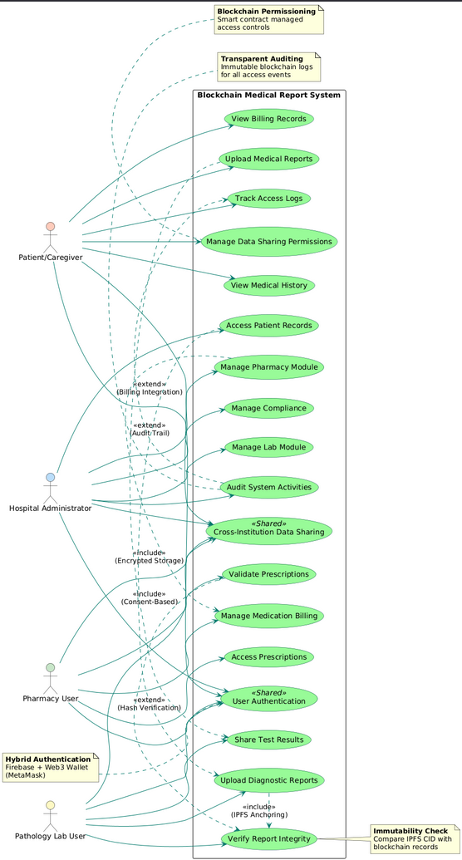

Figure Use Case digram

## **Sequence Diagram**

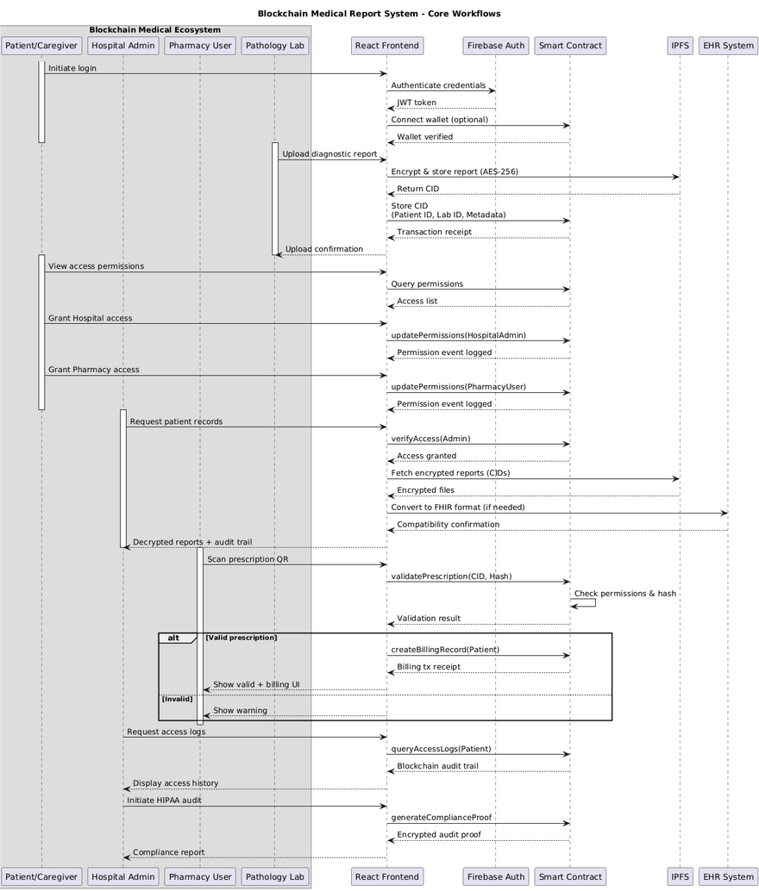

Figure Sequence diagram 1

## **Architecture of the Medical Report Management System**

### **Client-Side (Front-End)**

Client-Side (Front-End)

* React.js + HTML + CSS + JavaScript, this combination of technologies ensures all users - from elderly patients to busy medical staff - have consistent experience across devices while maintaining strict security protocols.
  + Build responsive, role-specific dashboards (Patient, Hospital Admin, Pharmacy, Lab).
  + Handle UI interactions like uploading reports, granting/revoking access, billing view.
  + Integrates Web3.js / Ethers.js for blockchain interaction.
* **Features:**
  + Cryptographic wallet login (MetaMask).
  + Real-time notifications (report uploaded, access request).
  + WCAG 2.1-compliant accessibility for patients and caregivers.

Server-Side & Decentralized Backend

For data management, use a hybrid architecture combining traditional and blockchain technologies:

* Node.js serves as the HIPAA-compliant API gateway, handling non-sensitive metadata
* Blockchain Layer (Ethereum/Hyperledger Fabric)
  + Stores access permissions, audit logs, smart contracts for data sharing.
  + Uses SHA-256 hashing to validate medical reports.
  + Guarantees immutability, consent management, and tamper-proof history.
* IPFS Storage secures encrypted medical reports using AES-256, with content-addressed hashes anchored on-chain
* uPort Identity Management replaces traditional auth, using digital signatures instead of passwords

The architecture ensures:

1. Data Integrity: On-chain hashing validates report authenticity
2. Zero-Trust Security: Wallet-based authentication eliminates central credential databases
3. Regulatory Compliance: Immutable audit trails satisfy HIPAA requirements
4. Patient Agency: Smart contracts enforce granular consent

Transforming traditional healthcare data silos into a patient-controlled ecosystem where security and accessibility coexist through blockchain's decentralized trust model.

Figure Architecture of the Website

## **Data Modeling**

Table 1 provides an overview of the advantages of Blockchain + NoSQL (Firestore) + IPFS hybrid architecture compared to traditional relational databases for medical report management.

|  |  |  |
| --- | --- | --- |
| **Aspect** | **Relational Databases (RDBMS)** | **Blockchain + NoSQL + IPFS (Proposed Model)** |
| **Data Structure** | Fixed schema (tables, rows, columns). | Flexible schema (JSON docs in NoSQL, immutable blockchain transactions, IPFS file hashes). |
| **Scalability** | Vertical scaling, limited for massive records. | Horizontal scaling with distributed blockchain nodes + sharded NoSQL collections. |
| **Data Integrity** | Integrity checks via primary/foreign keys. | Guaranteed immutability via blockchain consensus + SHA-256 hashing. |
| **Security & Compliance** | Relies on access controls, vulnerable to breaches. | End-to-end encryption, decentralized access, HIPAA/GDPR compliance through smart contracts & zero-knowledge proofs. |
| **File Storage** | Large files stored externally (BLOBs inefficient). | IPFS stores encrypted medical reports, blockchain keeps hash references for authenticity. |
| **Performance** | Slower with unstructured/large healthcare data. | Optimized query performance via Firestore for metadata, IPFS for bulk data, blockchain for logs. |
| **Auditability** | Manual logs, prone to tampering. | Immutable audit trails stored directly on blockchain. |
| **Data Types Supported** | Limited to structured tabular data. | Supports structured (Firestore), unstructured (IPFS reports), and transactional (Blockchain smart contracts). |

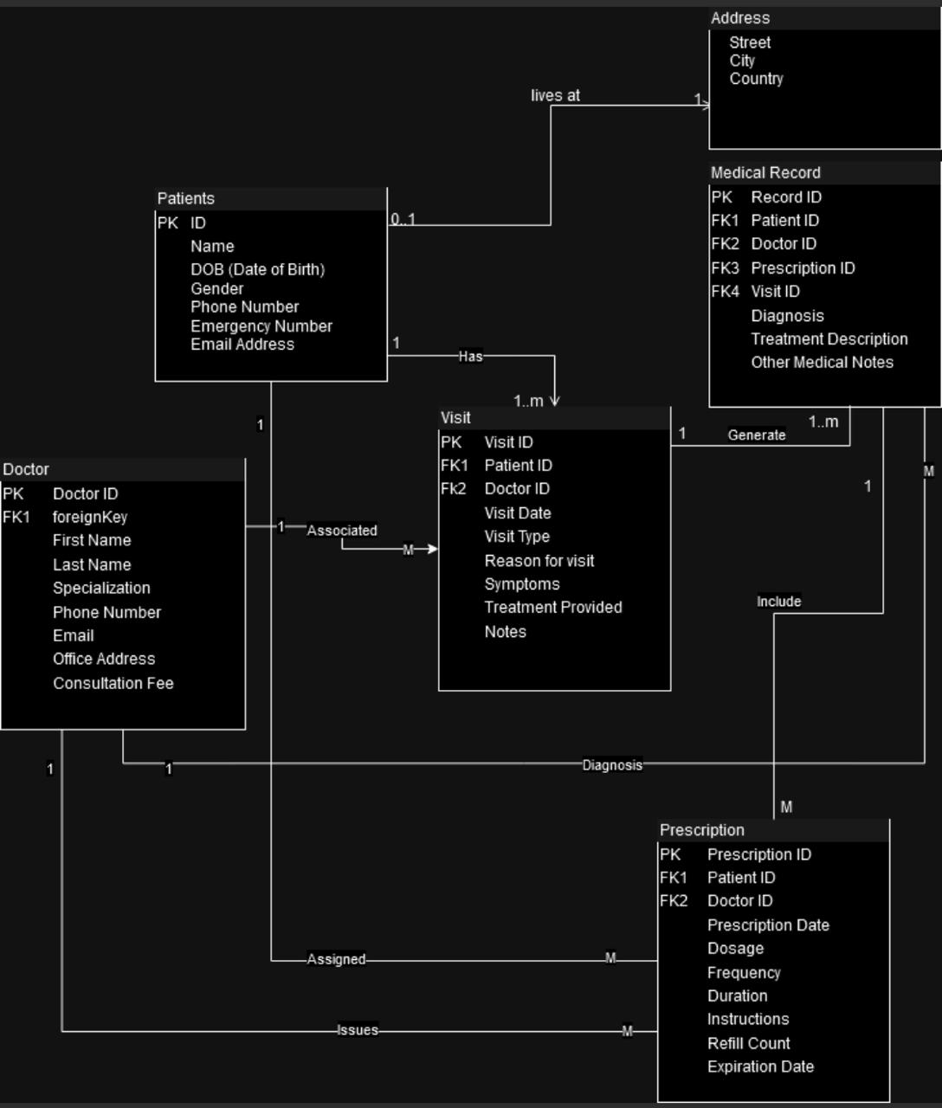

Figure Entity Relations diagram Sample: HOSPITAL

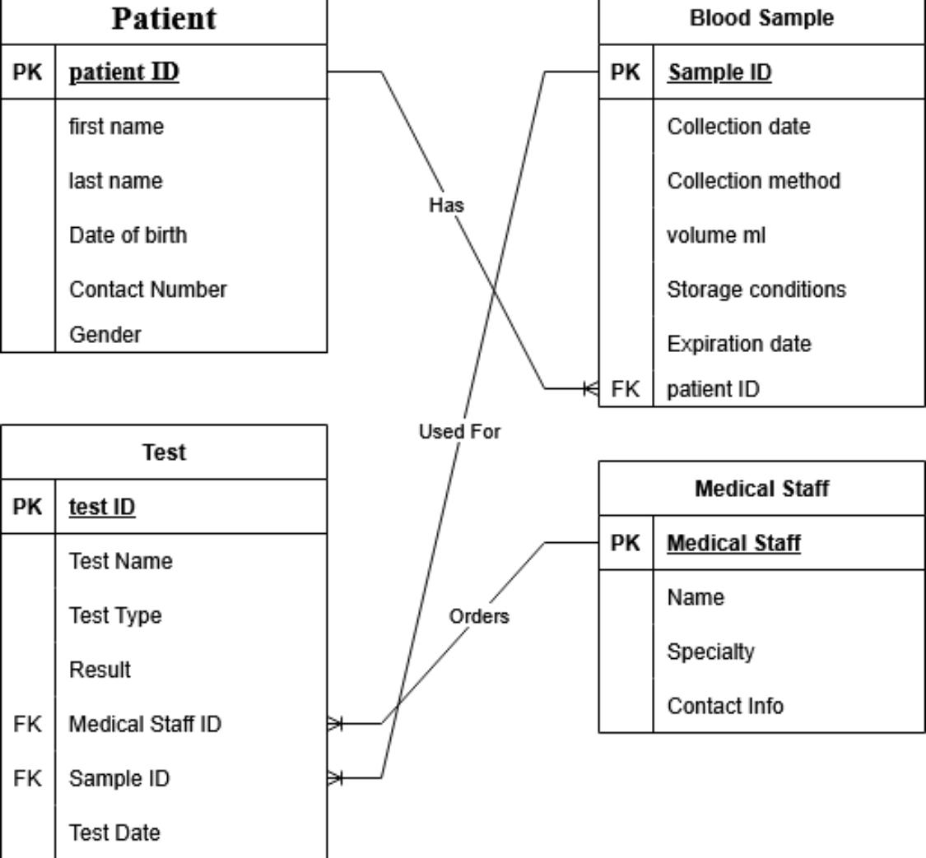

Figure Entity Relations diagram Sample: LAB

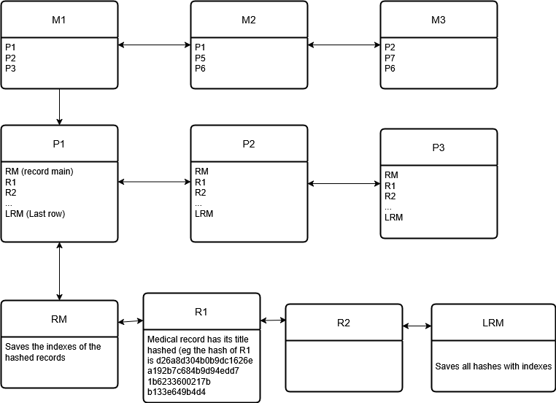

Figure represents the Blockchain architecture

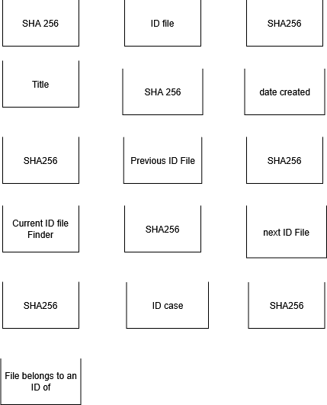

Figure represents the smart contract architecture

## **Technologies Used**

For the database and storage layer, we adopted a hybrid architecture instead of a traditional RDBMS (Relational database management system). Sensitive medical reports are stored in IPFS(InterPlanetary File System) in encrypted form, ensuring decentralization and tamper-proof backups. Metadata such as user roles, session details, and non-sensitive operational data is maintained in Firebase Firestore (NoSQL), which supports dynamic schema design and real-time updates. The blockchain (Ethereum/Hyperledger Fabric) is used to store audit trails, access permissions, and cryptographic hashes of reports to guarantee immutability and integrity. This distributed approach ensures compliance with healthcare regulations (HIPAA/GDPR) while maintaining high scalability and performance.

For the front-end, we utilized ReactJS due to its simplicity, performance, and ability to enhance user experience for multiple roles (Patient, Hospital Admin, Pharmacy, Pathology Lab). React’s component-based architecture allows modular dashboards tailored to different user types, improving maintainability and scalability. The virtual DOM ensures efficient rendering, so only modified sections update dynamically, leading to faster interactions when accessing reports, updating permissions, or generating billing details.

For the middleware, we integrated Web3.js/Ethers.js to connect the web app with the blockchain network. These libraries enable seamless execution of smart contracts for access control and consent management.

For authentication and access control, we employed Firebase Authentication integrated with cryptographic wallets (MetaMask), ensuring secure login via decentralized identifiers (DIDs) and role-based permissions.

Together, this technology stack — ReactJS (UI), Firebase (metadata & auth), Blockchain (immutability & smart contracts), and IPFS (encrypted report storage) — provides a secure, scalable, and user-friendly platform for managing and distributing medical reports.

## **Conclusion**

In this chapter, we described the functional and non-functional requirements, along with the use case and sequence diagrams. We also outlined the platforms and technologies used to implement the system. The integration of blockchain, IPFS, Firebase, and ReactJS ensures a secure, decentralized, and efficient framework for medical record management. The next chapter will focus on the System Analysis and Design.

# **Chapter 3**

# System Analysis

## **Introduction**

This chapter details the analysis, design, and implementation of the Blockchain-Enabled Medical Report Management and Distribution System. Unlike traditional centralized healthcare record systems that are prone to breaches, our approach leverages blockchain, IPFS, and Firebase to ensure security, transparency, and efficiency.

The objective is to build a secure platform for storing and distributing medical reports while maintaining accessibility and interoperability for patients, hospitals, pharmacies, and pathology labs. To achieve this, we designed a decentralized architecture where medical reports are encrypted and stored in IPFS, access permissions and audit trails are managed by smart contracts on the blockchain, and metadata is handled by Firebase Firestore for real-time updates.

This chapter outlines the system implementation process, including:

* Data modeling and integration of blockchain transactions with IPFS storage.
* Smart contract design for access control, consent management, and auditing.
* Front-end integration (ReactJS) with Web3.js/Ethers.js for blockchain communication.
* Authentication workflows using Firebase Authentication and cryptographic wallets.
* Testing and validation of report uploads, access permissions, and data retrieval workflows.

Through this hybrid implementation, the system ensures that medical data remains secure, immutable, and easily accessible only to authorized stakeholders, thereby aligning with healthcare compliance standards such as HIPAA and GDPR.

**Limitation**

Though our initial plan was to develop and deploy a custom private blockchain network for complete control over consensus, transaction speed, and node management, we encountered hardware and infrastructure limitations. Setting up a private blockchain requires multiple high-performance nodes, dedicated storage, and reliable networking infrastructure to maintain distributed consensus, which exceeded our available resources. We also used mongo db for authentications and non-senstive data instead of firebase.

As a result, we implemented the system using Ethereum as the blockchain platform for smart contract deployment and Pinata (an IPFS pinning service) for decentralized medical report storage. While this approach provided a practical and scalable solution, it introduced certain trade-offs:

* Dependency on Public Infrastructure: Using Ethereum means relying on an existing public blockchain network, which subjects the system to gas fees, network congestion, and transaction delays.
* Third-Party Storage Reliance: With Pinata handling IPFS storage, we sacrifice full autonomy over node management, since storage reliability partly depends on the provider’s uptime and performance.
* Scalability Constraints: Unlike a dedicated private blockchain where parameters can be customized, Ethereum’s shared ecosystem imposes limitations on throughput and transaction cost optimization.

Despite these limitations, the decision to use Ethereum and Pinata allowed us to prototype and validate the system effectively, ensuring real-world applicability while still maintaining a secure, decentralized, and HIPAA-compliant environment.

## **Data Modeling and Integration of Blockchain Transactions with IPFS Storage**

The foundation of the system lies in combining blockchain’s immutability with IPFS’s distributed storage. Initially we wanted to store medical reports on the block chain. However, medical reports are often large files, so we opted to first encrypt and then upload them to IPFS. IPFS generates a content identifier (CID) — a unique hash that ensures the file cannot be altered without detection. This CID is then stored on the blockchain ledger through a transaction, ensuring that the reference to the medical report is immutable and permanently auditable.  
In parallel, Firebase Firestore stores metadata such as user roles, timestamps, and temporary session details to allow for efficient real-time operations. This hybrid data model separates sensitive medical content (IPFS) from lightweight operational data (Firestore) while using blockchain to guarantee integrity and authenticity.

## **Smart Contract Design for Access Control, Consent Management, and Auditing**

Smart contracts act as the rules engine of the system. Each time a patient grants or revokes access to their medical records, a smart contract transaction is executed, updating permissions on the blockchain. Access rights are time-bound or role-specific, ensuring that hospitals, pharmacies, and labs only view the data they are authorized for.  
Additionally, smart contracts generate immutable audit logs, recording every interaction — such as report uploads, billing verifications, or lab updates — so stakeholders can trace when and how data was accessed. This guarantees transparency and supports compliance with healthcare regulations like HIPAA and GDPR.

## **Front-End Integration (ReactJS) with Web3.js/Ethers.js for Blockchain Communication**

The front-end application, built in ReactJS, provides role-based dashboards (Patient, Hospital Admin, Pharmacy, Pathology Lab). To interact with the blockchain, the React app integrates Web3.js or Ethers.js, enabling communication with Ethereum/Hyperledger smart contracts.  
Through this integration, patients can grant/revoke access with a simple click, hospitals can audit logs, pharmacies can verify prescriptions, and labs can upload reports — all while the underlying blockchain transactions happen transparently. This ensures the user experience remains smooth even though the backend is decentralized.

## **Authentication Workflows Using Firebase Authentication and Cryptographic Wallets**

Authentication in the system is multi-layered for maximum security. Firebase Authentication handles general login management, session handling, and identity verification. However, for blockchain-specific actions, users must authenticate with their cryptographic wallet (e.g., MetaMask).  
This dual approach provides both the convenience of Firebase’s real-time identity management and the decentralized security of blockchain wallets, ensuring that only verified and authorized users can perform sensitive operations such as uploading or accessing reports.

## **Testing and Validation of Report Uploads, Access Permissions, and Data Retrieval Workflows**

The final stage involves rigorous system testing and validation to ensure the workflows perform securely and efficiently. This includes:

* Report Upload Testing: Ensuring reports are encrypted, uploaded to IPFS, and correctly referenced on the blockchain.
* Access Permission Testing: Validating that only authorized roles (as defined by smart contracts) can view reports.
* Audit Log Verification: Confirming that every action (upload, access, revoke) is permanently recorded in the blockchain ledger.
* Performance Testing: Checking response times for retrieval from IPFS, Firestore queries, and blockchain transactions under peak loads.
* Security Testing: Simulating unauthorized access attempts to validate system resilience against breaches.

Through these validation steps, the platform demonstrates its ability to handle real-world healthcare scenarios while maintaining security, reliability, and compliance.

## **Conclusion**

The implementation of the Blockchain-Enabled Medical Report Management and Distribution System demonstrates the potential of combining blockchain, IPFS, Firebase, and ReactJS to address long-standing challenges in healthcare data security, integrity, and accessibility. By modeling medical data as encrypted IPFS files linked to immutable blockchain records, the system ensures that sensitive patient information remains tamper-proof and verifiable. The introduction of smart contracts enables automated, transparent, and role-based access control, allowing patients to retain ownership of their data while providing healthcare professionals with timely access.

The front-end integration with ReactJS and Web3.js/Ethers.js ensures that complex blockchain interactions are abstracted into user-friendly dashboards, delivering an intuitive experience for patients, caregivers, and healthcare providers alike. Authentication workflows leveraging Firebase and cryptographic wallets provide a dual layer of security, aligning the platform with global compliance standards such as HIPAA and GDPR.

Finally, comprehensive testing and validation confirm the system’s robustness in handling report uploads, access permissions, and retrieval under real-world conditions. Together, these implementation strategies highlight a scalable, reliable, and secure framework for medical record management, paving the way for broader adoption of blockchain-enabled healthcare ecosystems.

# **Chapter 4**

# Implementation

## **Introduction**

In response to the growing demand for secure, decentralized, and patient-centered healthcare platforms, our team embarked on the development of a Blockchain-Enabled Medical Report Management and Distribution System. The primary objective of this system is to ensure confidentiality, integrity, and controlled accessibility of medical data while providing a seamless experience for patients, healthcare providers, pharmacies, and pathology labs.

By leveraging blockchain technology, IPFS, Firebase, and ReactJS, the system delivers a robust framework where medical records are encrypted, immutable, and verifiable. Blockchain ensures that audit trails and access permissions cannot be tampered with, while IPFS provides a decentralized storage mechanism for medical reports. Firebase supports real-time authentication and metadata management, ensuring a smooth flow of operations across different user roles.

The web application is designed to provide **role-specific dashboards**, enabling:

* Patients and caregivers access their medical history, grant/revoke permissions, and monitor audit logs.
* Hospital administrators to oversee user roles, system policies, and audit trails.
* Pharmacy users manage billing, verify prescriptions, and view authorized patient data.
* Pathology labs to upload encrypted medical reports and validate report authenticity.

Our system emphasizes security, transparency, and user empowerment, offering a reliable, interactive, and compliant medical data management platform. By combining decentralization with accessibility, the project addresses one of the most pressing issues in healthcare: balancing data security with usability and interoperability.

## **Front-End Implementation (Client-Side)**

The front-end was developed using ReactJS, HTML5, CSS3, and JavaScript, ensuring a responsive, modular, and accessible interface. React’s component-based architecture was used to build role-specific dashboards for patients, caregivers, hospital administrators, pharmacy users, and pathology labs.

* **Login Page**: For the demo pre-set up users are shown, not to be included in the final product

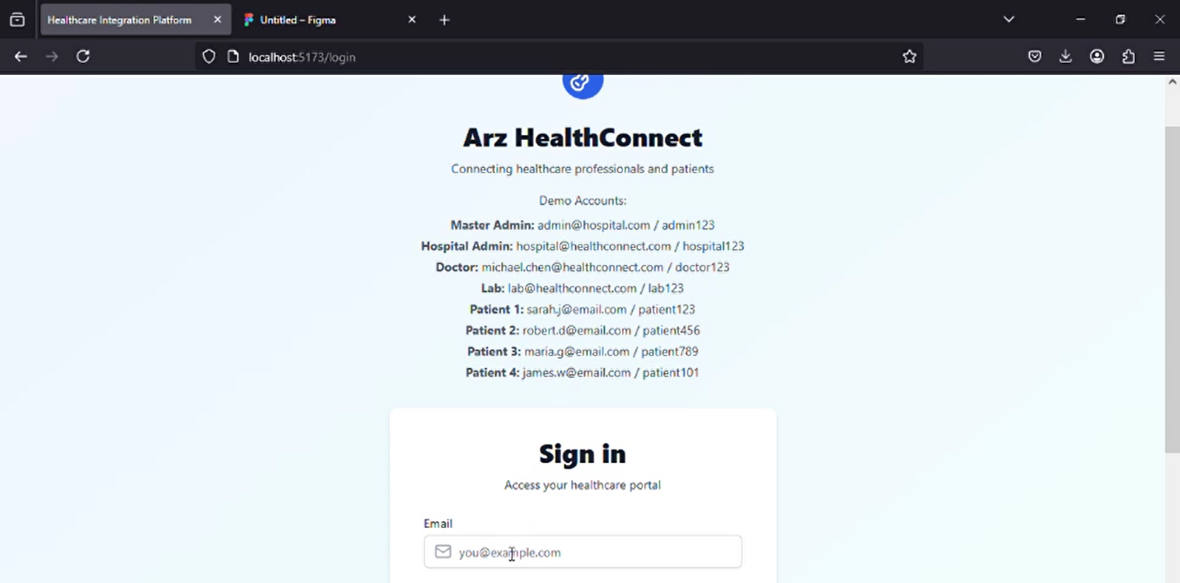

Figure Sign in

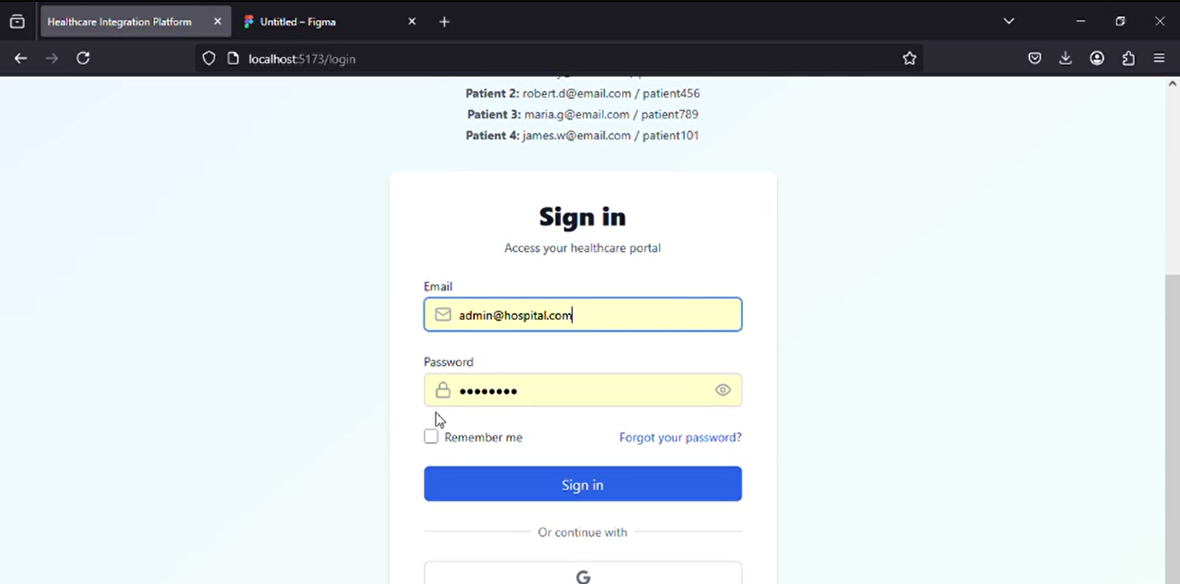

Figure Admin Hospital signing in

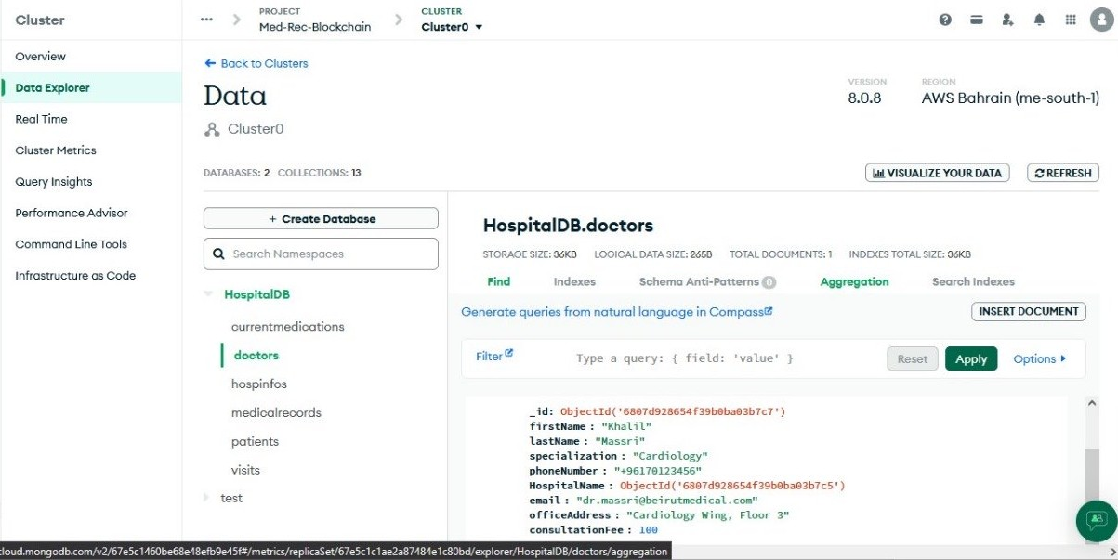

Figure mongoDB authentication

* **Patient Dashboard:** Provides access to encrypted reports, audit logs, and access control features.

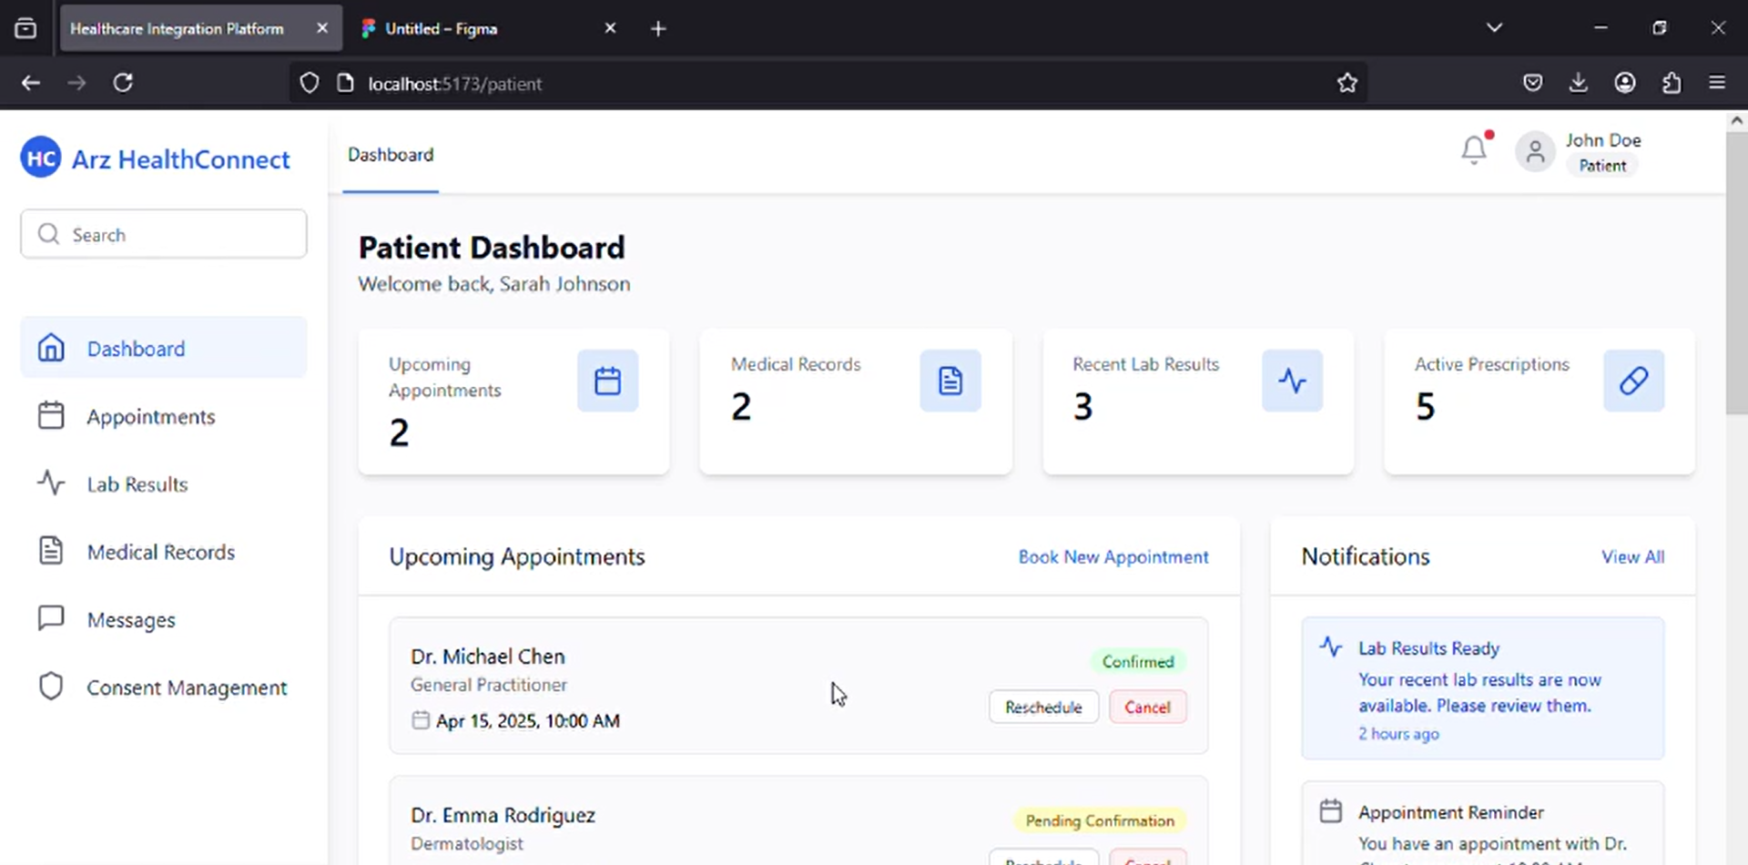

Figure Shows Patient Dashboard

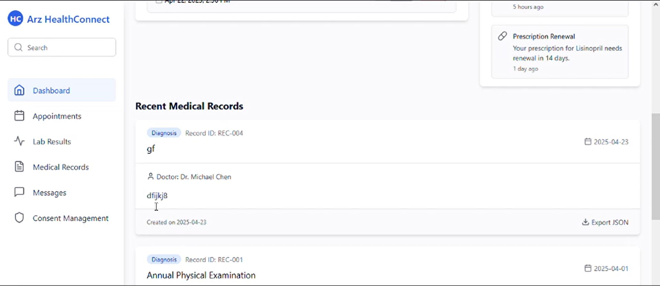

Figure shows new and old records

* **Hospital Administrator Dashboard:** Offers oversight of all user activities, system-wide policy updates, and audit logs.

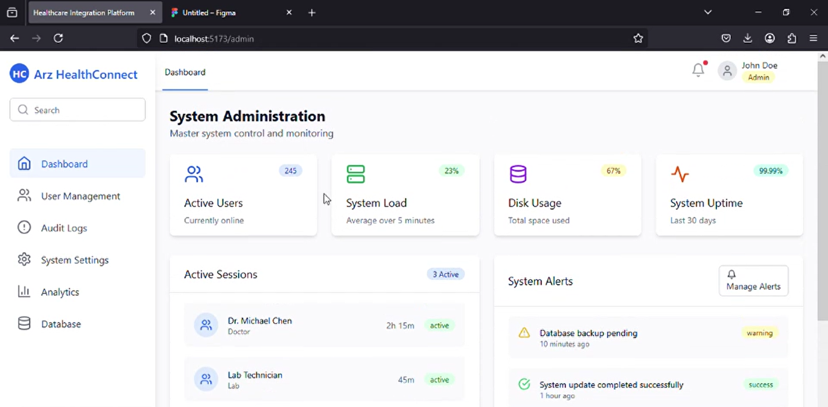

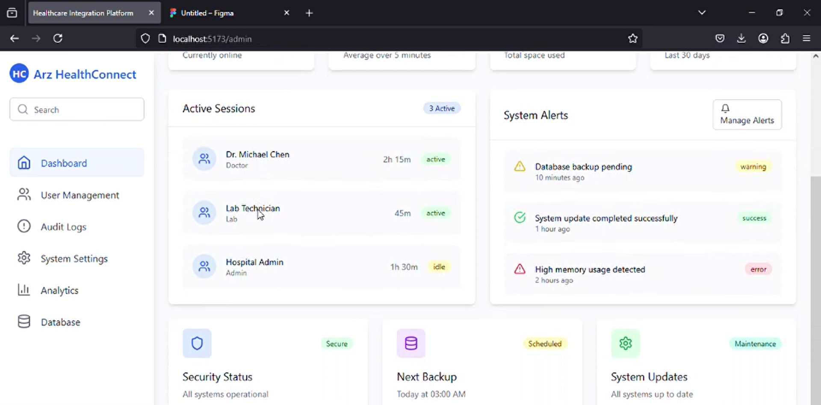

Figure shows Hospital Administrator Dashboard

* **Hospital Administrator User Management:** Manage staff access all patient records with patient consent.

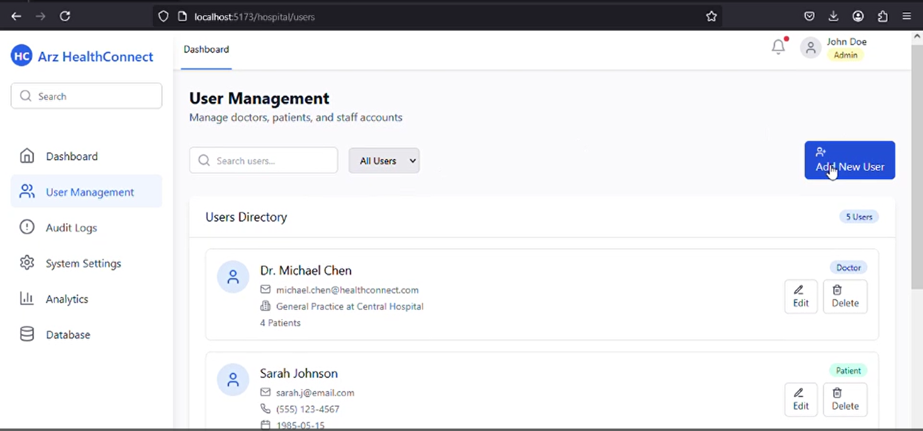

* **Hospital Administrator Audit page:** Audit all system activities through blockchain logs.

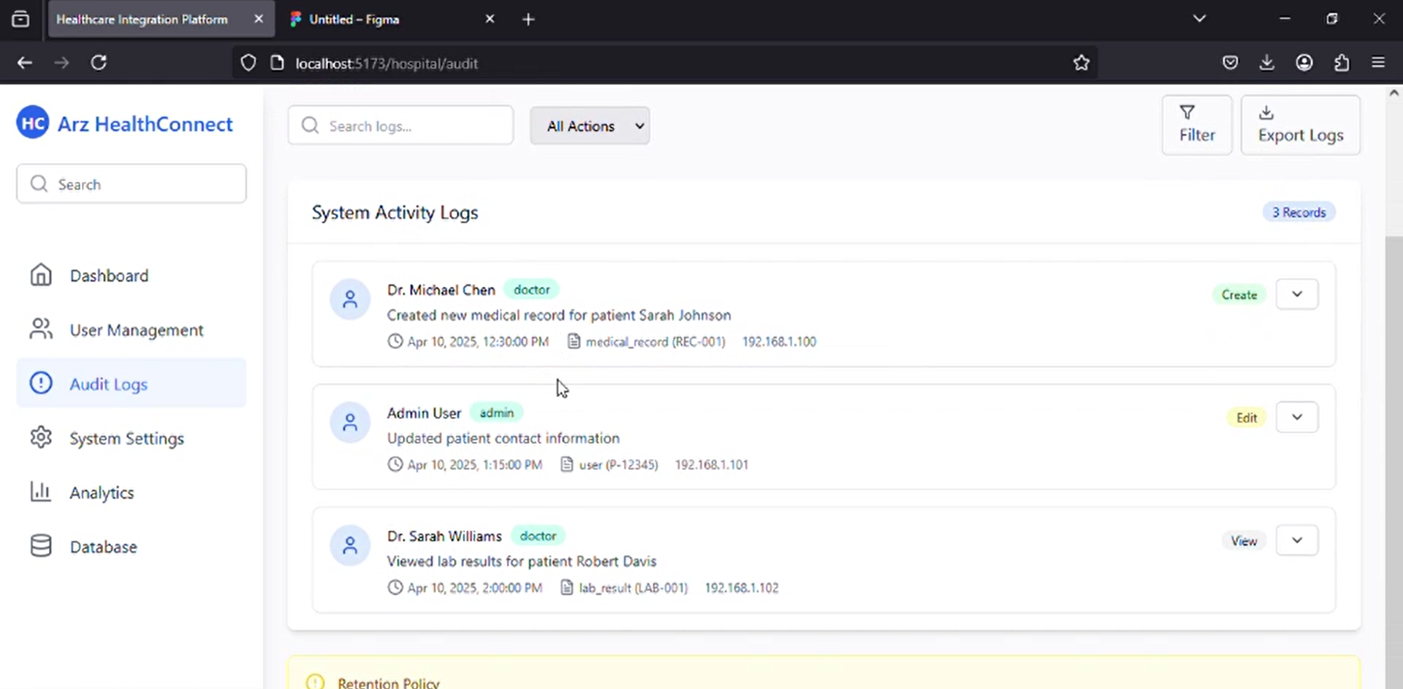

Figure Shows Audit logs

* **Pharmacy Dashboard:** Enables billing management and prescription verification.
* **Pathology Lab Dashboard:** Supports uploading encrypted reports and validating their authenticity.

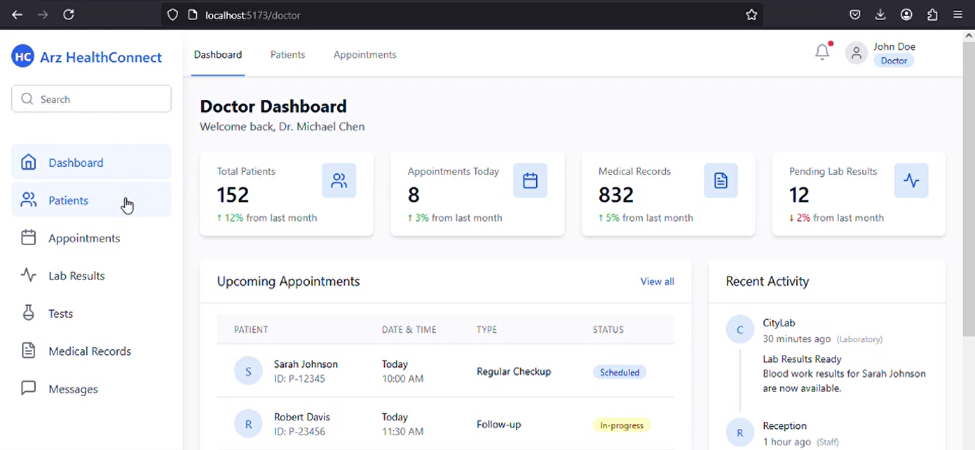

Figure shows Pathology Lab Dashboard

* **Pathology Lab Patient Overview:** Share test results with hospitals and patients based on granted permissions and upload diagnostic test results securely to IPFS.

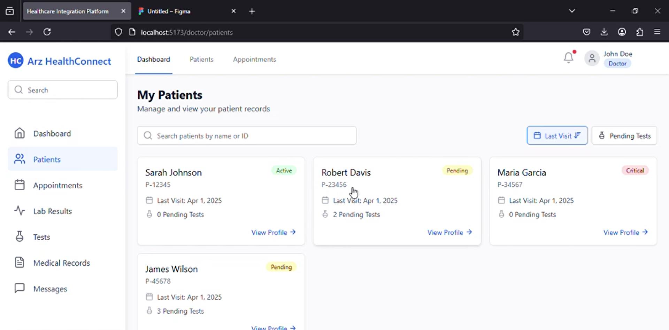

Figure All pathology patient overview

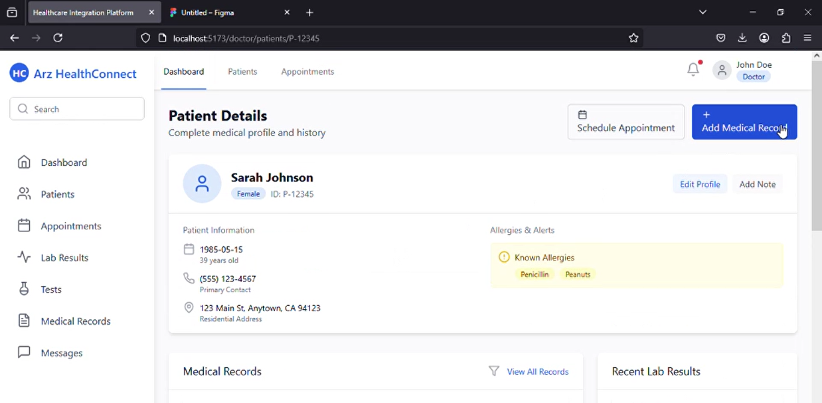

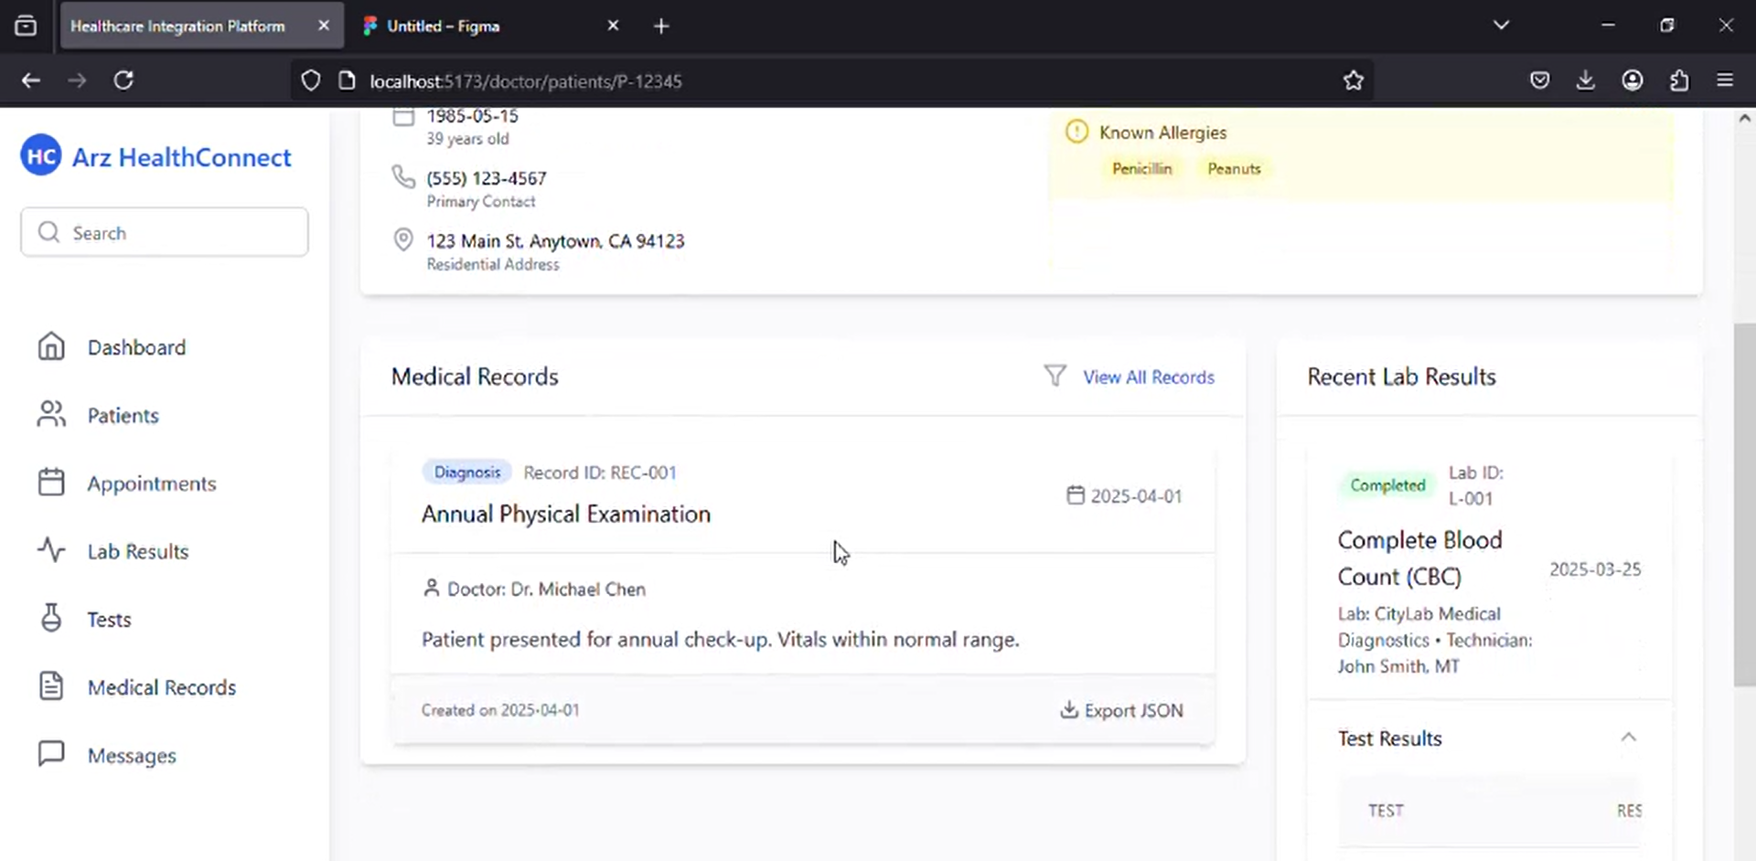

Figure Single patient overview

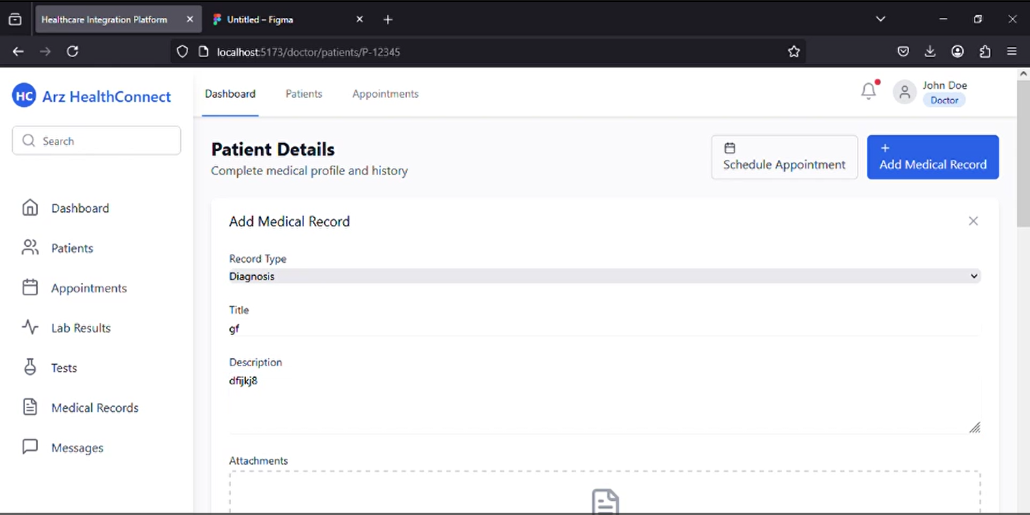

Figure Shows pathology lab uploading a record  
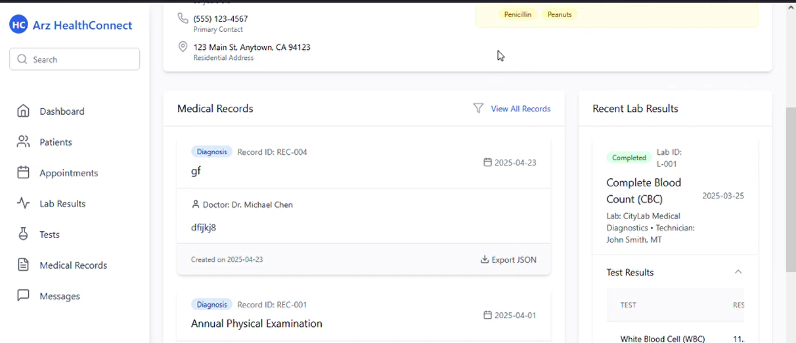

Figure shows pathology lab record uploaded and doctor exported result to json file as well

ReactJS was integrated with **Web3.js/Ethers.js** to enable **blockchain interactions** directly from the UI. For example, when a patient grants access to a doctor, a **smart contract transaction** is executed transparently through the interface.

## **Middleware and Blockchain Integration**

The middleware layer ensures smooth communication between the front-end, blockchain, and IPFS. Using Web3.js/Ethers.js, React components interact with smart contracts deployed on Ethereum.

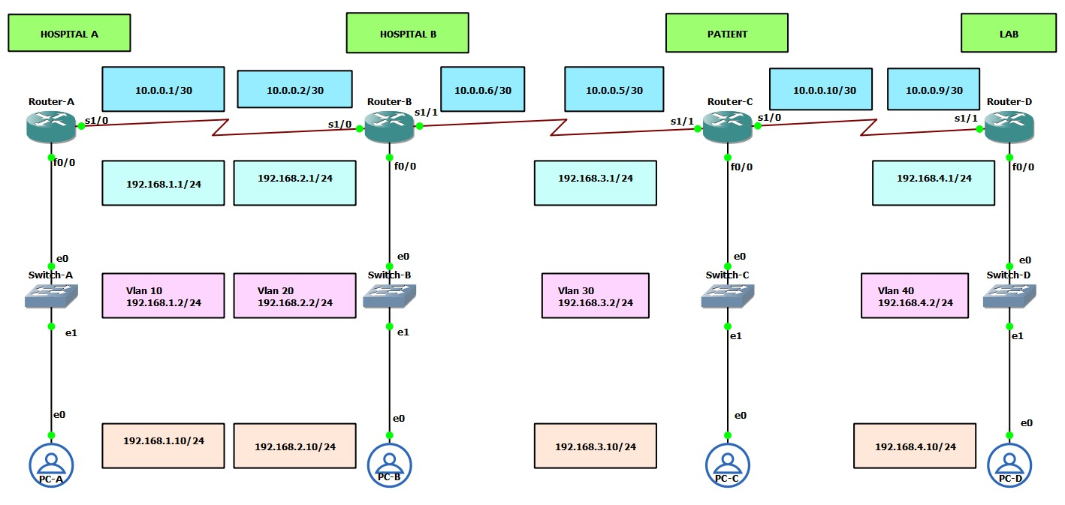

Figure Intial plan to use a private blockchain

* **Smart Contract Functions:**
  + Grant/Revoke Access: Patients control permissions dynamically.
  + Audit Logging: Every access or modification is permanently recorded.
  + Report Validation: CIDs (Content Identifiers) from IPFS are checked against blockchain hashes.

This design ensures **immutability, transparency, and role-based access control**, making unauthorized modifications impossible.

## **Data Storage and Management (IPFS + Firebase)**

a) IPFS Integration

Medical reports are first encrypted (AES-256), uploaded to IPFS, and assigned a unique Content Identifier (CID). The CID is stored on the blockchain to guarantee authenticity. IPFS ensures redundancy and decentralization, eliminating single points of failure.

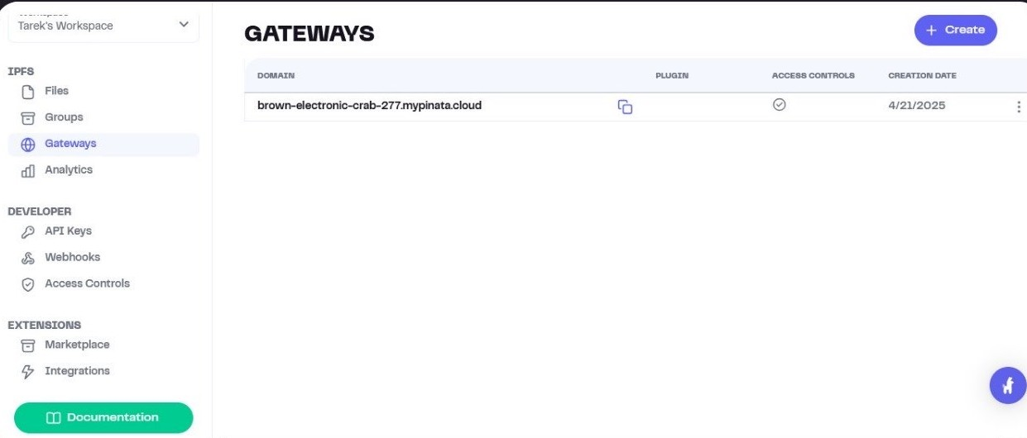

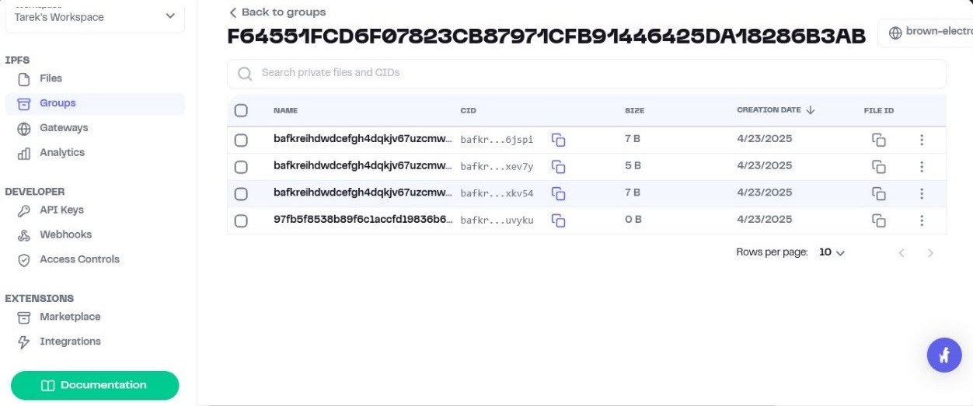

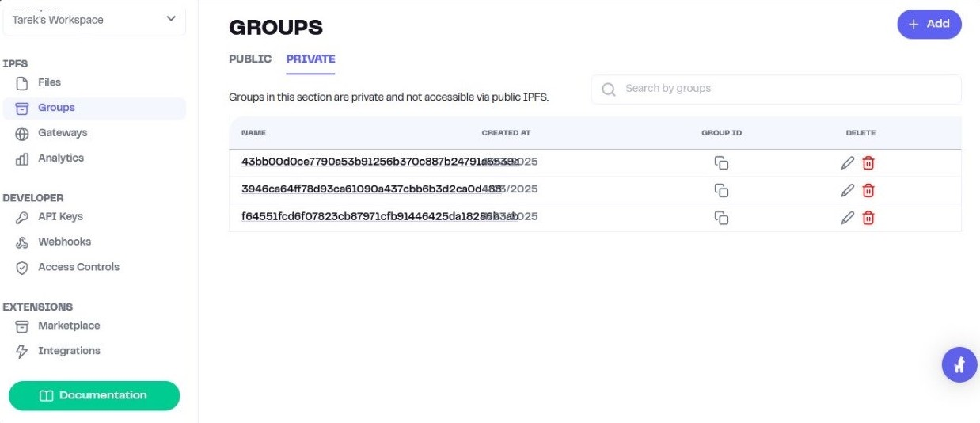

b) Firebase Firestore

While reports remain in IPFS, lightweight data such as user metadata, session data, and temporary logs are stored in Firestore (NoSQL). Its schema flexibility supports evolving requirements, and its real-time syncing enables notifications for report uploads, access approvals, and billing updates.

c) Firebase Storage

Used for non-sensitive media (e.g., profile images, hospital logos) to reduce blockchain/IPFS load.

## **Authentication Workflows**

Authentication combines Firebase Authentication with cryptographic wallets.

* Firebase Authentication manages basic user login, identity verification, and session handling.



Figure Used mongoDB instead of firebase due to constraints

* Cryptographic Wallets provide decentralized authentication via Decentralized Identifiers (DIDs), ensuring users prove ownership of their blockchain identity before performing actions like uploading reports or modifying permissions.

This dual-layer security ensures compliance with HIPAA/GDPR, where both centralized identity verification and decentralized ownership validation are required.

## **Testing and Validation**

To ensure system reliability and security, multiple testing strategies are proposed:

* **Unit Testing:** Smart contract functions (granting/revoking access, hashing, and auditing) were tested in isolation.
* **Integration Testing:** Verified seamless interaction between React front-end, blockchain layer, and IPFS storage.
* **Security Testing:** Conducted penetration testing to simulate unauthorized access attempts, validating the system’s resilience.
* **User Acceptance Testing (UAT):** Patients, doctors, and administrators tested role-specific dashboards to ensure usability.

## **Summary of Implementation**

The implementation of the system successfully integrates:

* ReactJS front-end for modular dashboards,
* Web3.js/Ethers.js middleware for blockchain communication,
* Ethereum/Hyperledger smart contracts for access control and auditing,
* IPFS for encrypted medical report storage, and
* Firebase for metadata, authentication, and real-time updates.

This hybrid architecture ensures security, scalability, usability, and compliance, effectively addressing challenges in traditional Electronic Health Record (EHR) systems.

# **Conclusion and Perspectives**

In conclusion, the development of our Blockchain-Enabled Medical Report Management and Distribution System represents a significant step forward in securing and managing sensitive healthcare data. By combining blockchain technology, IPFS storage, Firebase Authentication, and ReactJS front-end integration, our system addresses the growing need for data security, transparency, and controlled access in electronic medical records.

The system ensures that patients remain the true owners of their medical data, with the ability to grant or revoke access to healthcare providers, pharmacies, and pathology labs. Blockchain immutability guarantees trust and transparency, while smart contracts handle access control, consent management, and auditing. IPFS ensures efficient and decentralized file storage, reducing the risks of centralized database breaches.

From a usability perspective, the system offers a user-friendly and accessible web-based interface, allowing patients, hospitals, pharmacies, and labs to seamlessly interact within a secure digital ecosystem. By integrating cryptographic wallets and Firebase Authentication, the system balances ease of access with strong security protocols.

Looking ahead, we envision several enhancements:

* Integration with national and global EHR standards (HL7, FHIR) to improve interoperability across healthcare providers.
* Deployment of AI-driven analytics to support predictive healthcare, early diagnosis, and personalized treatment recommendations.
* Mobile application development to provide easier access for patients and caregivers on the go.
* Expanded role-based modules to include insurance providers and public health agencies for broader ecosystem adoption.
* Performance optimization for large-scale deployment, ensuring scalability in real-world hospital networks.

This project demonstrates the potential of blockchain to revolutionize healthcare data management, balancing security, privacy, and accessibility. With continuous improvement and stakeholder collaboration, the system can evolve into a comprehensive, interoperable, and patient-centered medical record management platform for the future of digital healthcare.

# References

Alder, S. (2018, January 4). *Largest Healthcare Data Breaches of 2017*. Retrieved from The HIPAA Journal: https://www.hipaajournal.com/largest-healthcare-data-breaches-2017/

Sahoo, S. K., Mishra, S. K., & Guru, A. (2023). Blockchain-based medical report management and distribution system. In *6G Enabled Fog Computing in IoT: Applications and Opportunities* (pp. 239-260). Cham: Springer Nature Switzerland.

Sammeta, N., & Parthiban, L. (2022). Hyperledger blockchain enabled secure medical record management with deep learning-based diagnosis model. *Complex & Intelligent Systems*, *8*(1), 625-640.

Han Y, Zhang Y, Vermund SH. Blockchain Technology for Electronic Health Records. Int J Environ Res Public Health. 2022 Nov 24;19(23):15577. doi: 10.3390/ijerph192315577. PMID: 36497654; PMCID: PMC9739765.

Azaria, A. (2016). *MedRec: Blockchain for Medical Data Access*. MIT.

UAE Riayati. (2023). *Unified Patient Medical Records*. UAE Government|  
Gotterbarn , D., Brinkman, B., Flick, C., Kirkpatrick, M., Miller, K., Varansky, K., Anderson, E., Anderson, R., Bruckman, A., Carter, K., Davis, M., Duquenoy, P., Epstein, J., Kimppa, K., Kisselburgh, L., Kumar, S., McGettrick, A., Milic-Frayling, N., Oram, D., … Waguespack, L. (2018b, June 22). The code affirms an obligation of computing professionals to use their skills for the benefit of society. Code of Ethics.

# **Appendix**

**ACM Code of Ethics and Professional Conduct**

The ACM Code of Ethics and Professional Conduct has been carefully followed during the development of the Blockchain-Enabled Medical Report Management and Distribution System, as outlined by Gotterbarn et al. (2018). Below are the key guidelines from the ACM Code of Ethics and Professional Conduct applied throughout this project:

1. **GENERAL ETHICAL PRINCIPLES.**

A computing professional should...

* 1. Contribute to society and human well-being, recognizing that patients, healthcare providers, caregivers, and administrators are all impacted by the outcomes of this system.
  2. Avoid harm by ensuring medical reports remain secure, tamper-proof, and accessible only to authorized users, thereby preventing data breaches or misuse.
  3. Be honest and trustworthy in handling sensitive medical data, ensuring transparency in system design, encryption mechanisms, and blockchain transactions.
  4. Be fair and take action not to discriminate by designing the system so that access to medical reports is equal for all authorized stakeholders, regardless of institution or role.
  5. Respect the work of others by acknowledging contributions in blockchain, cryptography, and medical informatics research that informed the system’s development.
  6. Respect user privacy, ensuring all patient health data is encrypted, stored securely in IPFS, and accessible only with patient consent.
  7. Honor confidentiality when handling personal health information (PHI), ensuring compliance with HIPAA and GDPR regulations.

1. **PROFESSIONAL RESPONSIBILITIES.**

A computing professional should...

* 1. Strive for high quality in system design, including blockchain smart contracts, IPFS integration, and user interfaces.
  2. Maintain high standards of professional competence and conduct, applying ethical and technical best practices in healthcare IT, blockchain, and data security.
  3. Know and respect existing legal and ethical guidelines, such as healthcare privacy regulations, patient consent rules, and data-sharing policies.
  4. Accept and provide professional review, ensuring peer validation of smart contracts, encryption workflows, and authentication protocols.
  5. Evaluate the system’s performance comprehensively, including risks, scalability, and potential vulnerabilities in data sharing and access control.
  6. Perform work only in areas of competence, ensuring that blockchain engineering, healthcare domain expertise, and cybersecurity practices are applied effectively.
  7. Foster public awareness and understanding of the system, educating patients and healthcare providers on its purpose, benefits, and limitations.
  8. Access patient data only when authorized, ensuring all interactions are governed by patient consent and cryptographic verification.
  9. Design secure, robust, and user-friendly systems, protecting medical data from unauthorized access while keeping interfaces simple for healthcare professionals and patients.

1. **PROFESSIONAL LEADERSHIP PRINCIPLES.**

A computing professional, especially one in a leadership role, should...

1. Ensure that public good is the primary concern, prioritizing patient well-being, privacy, and data security over organizational or financial gain.
2. Encourage and evaluate social responsibilities, such as transparency in how access permissions, audit trails, and consent management are handled.
3. Manage resources responsibly, ensuring the development team delivers a secure, efficient, and ethical medical report management platform.
4. Support policies aligned with the Code, embedding ethical safeguards into both technical design and user workflows.
5. Foster professional growth, encouraging team members to stay up to date with advancements in blockchain, cybersecurity, and healthcare informatics.
6. Use care when modifying or retiring the system, ensuring continuity of medical data availability and compliance with healthcare regulations.
7. Recognize the sensitivity of healthcare systems, acknowledging that failures or ethical lapses could affect patient safety, trust, and legal compliance.
8. **COMPLIANCE WITH THE CODE.**

A computing professional should...

* 1. Uphold, promote, and respect the ACM Code of Ethics throughout the development, deployment, and maintenance of the medical report management system.
  2. Treat violations of the Code as inconsistent with professional standards, ensuring accountability within the development team and healthcare IT community.